sgRNAcas9 user manual

Latest updates. 28 Jul 15
1. sgRNAcas9_3.0.5.zip (Standalone installer package)
sgRNAcas9 can design sgRNA for any species!
It's a command-line tool, which can run on the Windows, Mac OS X and Linux system.
This software requires the pre-install Perl on the computer. See the README.txt file for detailed instruction.
Manually download and install Perl for your computer (http://www.perl.org/).
Sequence Format Converter (FASTA file): http://www.simgene.com/ReadSeqor http://sequenceconversion.bugaco.com/converter/biology/sequences/
Ensembl Genome Browser, manually download human, mouse, rat, pig etc. genome DNA FASTA files from FTP Download (http://asia.ensembl.org/info/data/ftp/index.html?redirect=no) website.

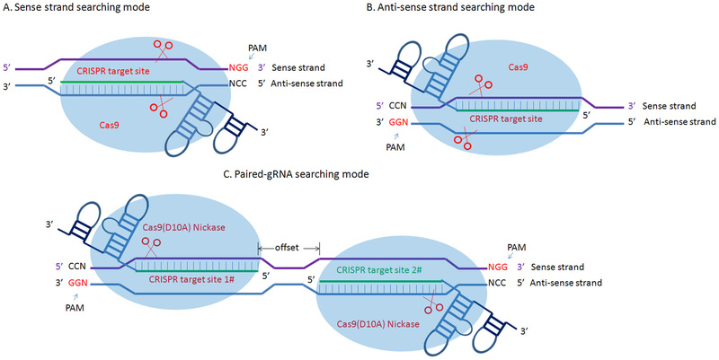

Usage example (for Windows system):
(1) sense strand searching mode
perl sgRNAcas9_3.0.5.pl -i hEMX1_example.txt -x 20 -l 40 -m 80 -g genome_example.fa -o s -t s -v w -n 5

(2) anti-sense strand searching mode
perl sgRNAcas9_3.0.5.pl -i hEMX1_example.txt -x 20 -l 40 -m 80 -g genome_example.fa -o a -t s -v w -n 5

(3) both strand searching mode
perl sgRNAcas9_3.0.5.pl -i hEMX1_example.txt -x 20 -l 40 -m 80 -g genome_example.fa -o b -t s -v w -n 5

(4) paired-gRNA searching mode
perl sgRNAcas9_3.0.5.pl -i hEMX1_example.txt -x 20 -l 40 -m 80 -g genome_example.fa -o b -t p -v w -n 5 -s 5 -e 35

Usage example(for linxu system):
Using the chmod command to change the access mode of Seqmap program(in the "Seqmap" file).
chmod +x seqmap-1.0.12-linux
chmod +x seqmap-1.0.12-linux-64

(1) sense strand searching mode
perl sgRNAcas9_3.0.5.pl -i hEMX1_example.txt -x 20 -l 40 -m 80 -g genome_example.fa -o s -t s -v l -n 5
(2) anti-sense strand searching mode
perl sgRNAcas9_3.0.5.pl -i hEMX1_example.txt -x 20 -l 40 -m 80 -g genome_example.fa -o a -t s -v l -n 5
(3) both strand searching mode
perl sgRNAcas9_3.0.5.pl -i hEMX1_example.txt -x 20 -l 40 -m 80 -g genome_example.fa -o b -t s -v l -n 5
(4) paired-gRNA searching mode
perl sgRNAcas9_3.0.5.pl -i hEMX1_example.txt -x 20 -l 40 -m 80 -g genome_example.fa -o b -t p -v l -n 5 -s 5 -e 35

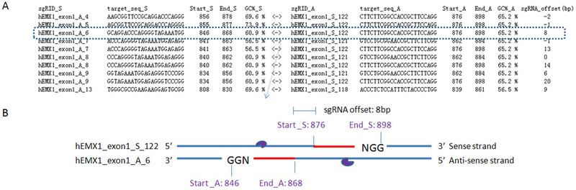

2. sgRNAcas9_Java (GUI)
Manually download and install Java (alsoknown as Java Runtime Environment or JRE) for your computer (http://www.java.com/zh_CN/).
Manually download and install Perl for your computer (http://www.perl.org/).

3. There are 23 columns in the sgRNAcas9 output file. Their meanings are:
field meaning
sgRID ID of the CRISRP target site
Start start sites
End End sites
CRISPR_target_sequence CRISRP target sequence(5'-3')
GC% GC content
OT annotation of off-targets with No.of mismatches <=5
0M(on-/off-) on target site, if 0M >1, Repeat gene? or off-target sites with 0 bp mismatch
1M off-target sites with 1 bp mismatch
2M off-target sites with 2 bp mismatches
3M off-target sites with 3 bp mismatches
4M off-target sites with 4 bp mismatches
5M off-target sites with 5 bp mismatches
No.OT total number of off-target sites
POT annotation of off-targets with perfect match to the 12-nt seed region of the sgRNA (No.of mismatches <=5)
0M(on-/off-) perfect match to the 12-nt seed region of the sgRNA, outer segments with 0 mismatch
1M perfect match to the 12-nt seed region of the sgRNA, outer segments with 1 mismatch
2M perfect match to the 12-nt seed region of the sgRNA, outer segments with 2 mismatches
3M perfect match to the 12-nt seed region of the sgRNA, outer segments with 3 mismatches
4M perfect match to the 12-nt seed region of the sgRNA, outer segments with 4 mismatches
5M perfect match to the 12-nt seed region of the sgRNA, outer segments with 5 mismatches
No.POT total number of off-targets sites with perfect match to the 12-nt seed regionof the sgRNA
Risk_evaluation evaluation of risk

Risk:
Discard > High_risk > moderate_risk> low_risk > repeat_sites_or_bad ? > Best

